Module 12: Cultural Perspectives in Storytelling
making storytelling a powerful cultural tool.
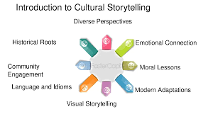
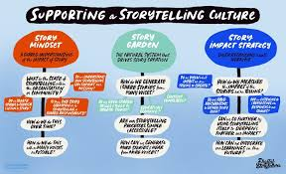
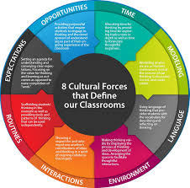
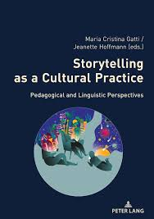

Module Metadata: Cultural Perspectives in Storytelling (1 Hour)
Short Description
Storytelling is deeply rooted in culture, history, and tradition, serving as a bridge between generations and shaping collective identity. Across different societies, storytelling preserves heritage, reflects historical events, and evolves with time.
Explore storytelling across cultures and generations. This module examines how traditions, historical events, and digital innovation shape narratives — empowering learners to preserve heritage and adapt stories for diverse audiences and platforms.
Long Description
Storytelling is a cultural lifeline — a way to remember, resist, and reimagine. In this module, learners will explore storytelling traditions from Africa, Native America, Japan, Hawaii, and the West, uncovering how each reflects values, beliefs, and historical experiences. They’ll analyze how war, migration, and colonialism influence narrative forms, and how oral, written, and digital storytelling preserve identity across generations. Learners will also practice adapting stories from other cultures, building intercultural fluency and creative confidence. These skills support not only cultural preservation but also entrepreneurial ventures in education, media, and community programming.
Aims
- To explore storytelling traditions across diverse cultures.
- To examine how historical events shape narrative forms and themes.
- To highlight methods of preserving and adapting stories across generations and platforms.
Objectives
By the end of this module, learners will be able to:
- Identify key features of storytelling traditions from multiple cultures.
- Analyze the impact of historical events on storytelling practices.
- Compare oral, written, and digital methods of story preservation.
- Adapt traditional stories for modern audiences and intercultural contexts.
Learning Outcomes
Learners will:
- Demonstrate understanding of cultural diversity in storytelling.
- Reflect on how stories preserve heritage and respond to historical change.
- Apply adaptation techniques to traditional stories from other cultures.
- Begin to position intercultural storytelling as a tool for education, digital media, and creative enterprise.

The Role of Storytelling in Different Cultures
Storytelling is universal, yet each culture has its own distinct traditions that reflect its values and beliefs2.
- African Storytelling – Often oral, passed down by griots (storytellers/historians), emphasizing community, wisdom, and ancestry.
- Native American Storytelling – Explains natural phenomena, spiritual beliefs, and tribal history through myths and legends.
- Japanese Folktales – Feature spirits, animals, and moral lessons, reinforcing harmony with nature.
- Hawaiian Storytelling – Includes mele (songs), oli (chants), and hula (dance) to preserve history.
- Western Storytelling – Often individualistic, focusing on personal growth and self-discovery.
Each tradition shapes identity, reinforces values, and connects people to their heritage.

How Historical Events Shape Storytelling Traditions
Historical events influence storytelling, shaping narratives that reflect societal changes5.
- War & Resistance – Stories of resilience emerge from struggles (e.g., Nelson Mandela’s journey).
- Migration & Diaspora – Tales of displacement and adaptation preserve cultural identity.
- Colonialism & Oppression – Many indigenous stories reflect survival and resistance.
- Technological Advancements – Digital storytelling modernizes traditional narratives.
Example: African oral traditions preserve history through spoken word, ensuring continuity despite colonial disruptions.

Preserving Stories Across Generations
Stories are passed down through oral traditions, written records, and digital archives7.
- Oral Storytelling – Elders share stories to educate younger generations.
- Written Documentation – Books, manuscripts, and historical records safeguard narratives.
- Digital Storytelling – Online platforms and recordings ensure accessibility.
- Community Storytelling – Festivals and gatherings keep traditions alive.
Example: Filipino migration stories are preserved through oral histories and digital archives, strengthening cultural ties.

Exercise: Research storytelling traditions from two different cultures and note similarities/differences.

Assignment: Adapt a traditional story from a culture outside your own and perform it.

